FCN
Duality AI Hackathon Submission
Team: Ikigai
FCN 8s with VGG16 encoder: dense per-pixel classification in off road scenes via learned multi scale skip fusions.

Architecture: FCN | Best IoU: 0.3119

Methodology

Problem Statement
Off road autonomous navigation requires robust scene understanding across heterogeneous terrain types including dense vegetation, loose soil, boulders, and sky. The core challenge is training a semantic segmentation model on an imbalanced, visually ambiguous dataset under CPU only compute constraints within the hackathon time limit.

Step by Step Process
- Dataset Preparation: Used the Offroad Segmentation Training Dataset comprising RGB images and pixel level segmentation masks across 10 semantic classes (Background, Trees, Lush Bushes, Dry Grass, Dry Bushes, Ground Clutter, Logs, Rocks, Landscape, Sky). Raw mask pixel values were remapped from sparse label values {0, 100, 200, 300, 500, 550, 700, 800, 7100, 10000} to compact class indices 0 9.
- Dataset Split & Image Resizing: Images were loaded from the official train/val split. All images were resized to 128×128 pixels for memory-efficient CPU training. Batch size was set to 4 to balance memory usage and gradient stability.
- Data Augmentation & Filtering: Applied random horizontal flipping and normalization using ImageNet mean/std ([0.485, 0.456, 0.406] / [0.229, 0.224, 0.225]) to all training images. Class frequency analysis was performed to identify severely underrepresented categories (< 5% of total pixels).
- Class Imbalance Strategy: Computed per-class pixel frequencies across the training set and derived inverse frequency class weights. These weights were applied to the Cross Entropy loss function so that rare classes (e.g., Logs, Dry Bushes) contributed proportionally more to the gradient signal.
- Architecture Selection Why FCN 8s: FCN 8s was selected over FCN 16s and FCN 32s because its pool3 skip connection provides the finest spatial resolution. Heavier architectures (e.g., DeepLabV3+, SegFormer) were ruled out due to CPU only compute constraints and the hackathon's time limit. The VGG16 backbone offered a well-understood feature hierarchy with available pretrained weights.
- Model Training: The FCN 8s model was trained for 11 epochs using the Adam optimizer with an initial learning rate of 1e-4 and a step based learning rate scheduler. Weighted Cross Entropy loss was used throughout. The best checkpoint (highest validation mean IoU) was saved automatically.
- Evaluation Protocol: After training, the best checkpoint was loaded and evaluated on the held-out validation set. Per-class IoU, mean IoU (mIoU), confusion matrix, and failure case examples were computed to comprehensively assess model performance.

Architecture Overview
FCN 8s uses a VGG16 encoder with fully convolutional layers replacing FC layers. Multi scale predictions from pool3, pool4 and pool5 are fused via learned upsampling for fine grained segmentation. FCN 8s was chosen over FCN 16s/32s for its finer spatial resolution from the additional pool3 skip connection, and over heavier Transformer based models to stay within CPU only compute constraints.

Training Strategy
Trained from scratch with a VGG16 based encoder. Cross entropy loss with class weighting was applied alongside Adam optimization with a step based learning rate scheduler. The best model checkpoint was saved based on peak validation mIoU.
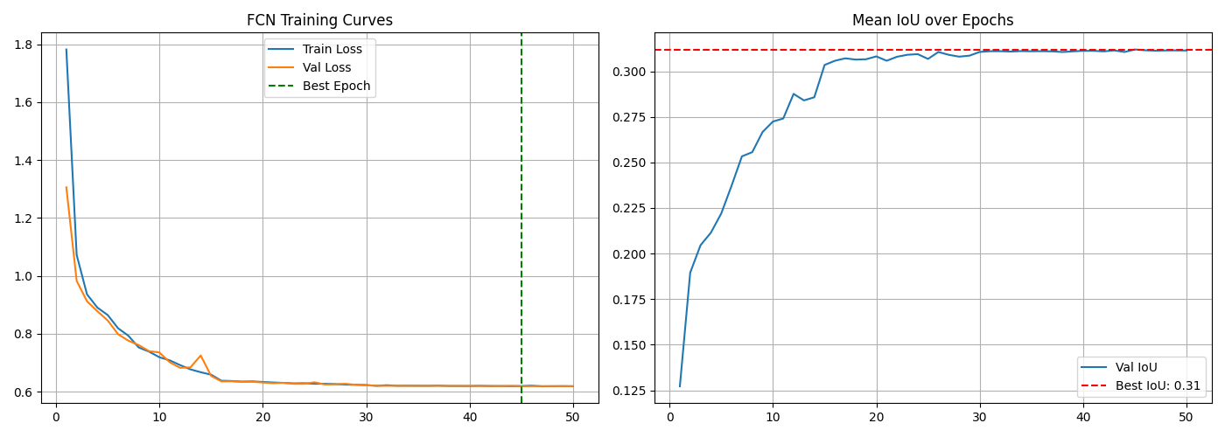

Results & Performance Metrics

Overall Performance
Metric | Value
Best Mean IoU | 0.3119
Final Mean IoU | 0.3114
Best Epoch | 45
Convergence Epoch | 12
Final Train Loss | 0.6185
Final Val Loss | 0.6189
Model Size (MB) | 128.47
Parameters (M) | 33.67

Per-Class IoU Performance
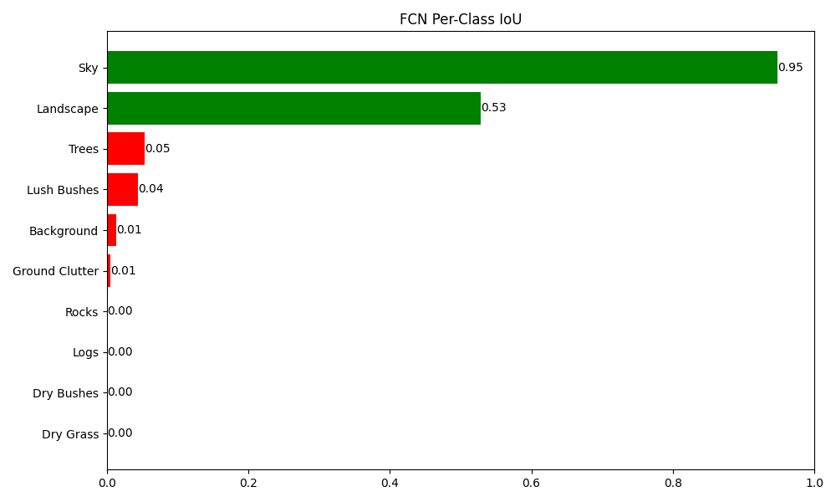
Class | IoU | Status
Sky | 0.9483 | Good
Landscape | 0.5281 | Good
Trees | 0.0539 | Poor
Lush Bushes | 0.0443 | Poor
Background | 0.0131 | Poor
Ground Clutter | 0.0051 | Poor
Dry Grass | 0.0000 | Failed (0.00)
Dry Bushes | 0.0000 | Failed (0.00)
Logs | 0.0000 | Failed (0.00)
Rocks | 0.0000 | Failed (0.00)

Confusion Matrix
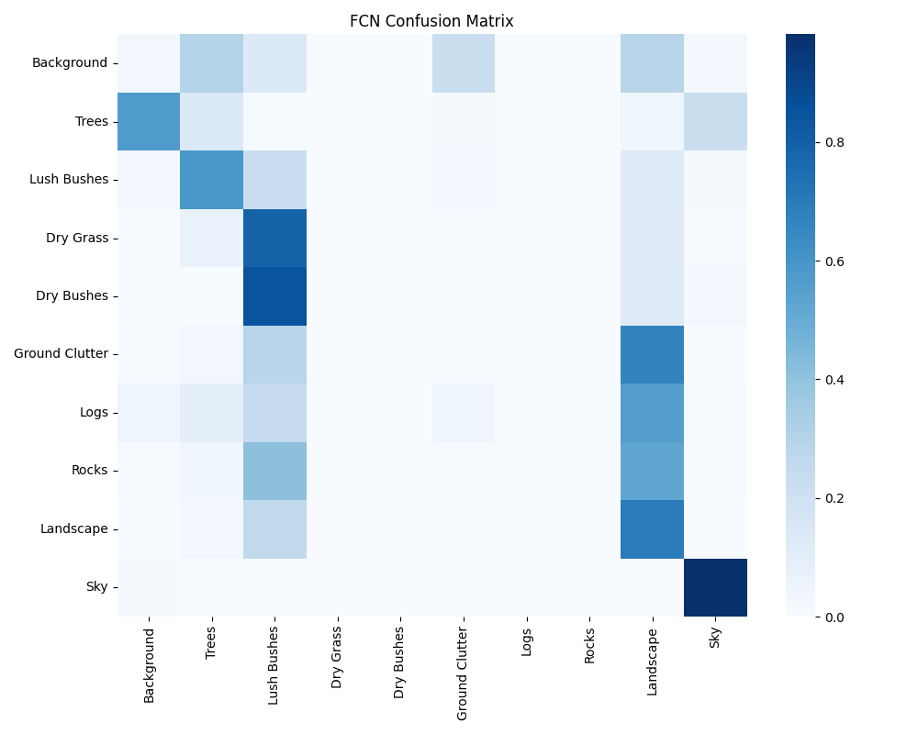
The most common misclassification pairs observed were: Dry Bushes mistaken as Lush Bushes, Dry Grass mistaken as Lush Bushes, Ground Clutter mistaken as Landscape. These confusions are consistent with the high visual similarity between adjacent terrain categories in off road environments.

Prediction Examples
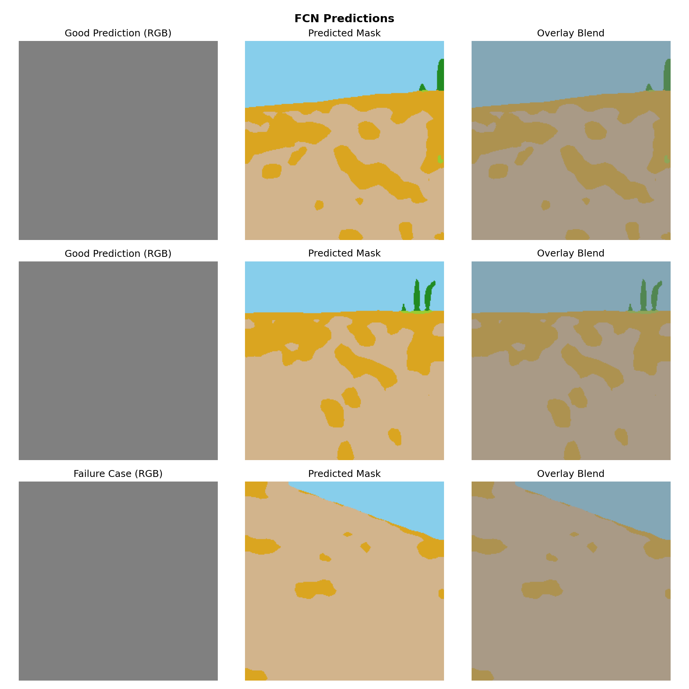

Challenges & Solutions

Challenge 1: Severe Class Imbalance
Problem: The classes Background, Trees, Dry Bushes, Ground Clutter, Logs, Rocks accounted for less than 5% of validation pixels, while dominant classes (Sky) occupied more than 30% each. Without intervention, the model would ignore rare classes entirely.
Fix Applied: We computed per-class pixel frequencies across the full training set and derived inverse-frequency class weights. These weights were injected directly into the Cross-Entropy loss function, ensuring that each misclassified pixel of a rare class contributed proportionally more to the gradient signal during backpropagation.

Challenge 2: Training Stability
Problem: Training was stable throughout.
Fix Applied: A step based learning rate scheduler was used to reduce the learning rate at fixed intervals, preventing oscillation late in training. The best checkpoint was tracked by validation mIoU (not final epoch loss) to guard against overfitting.

Challenge 3: Visually Ambiguous Class Discrimination
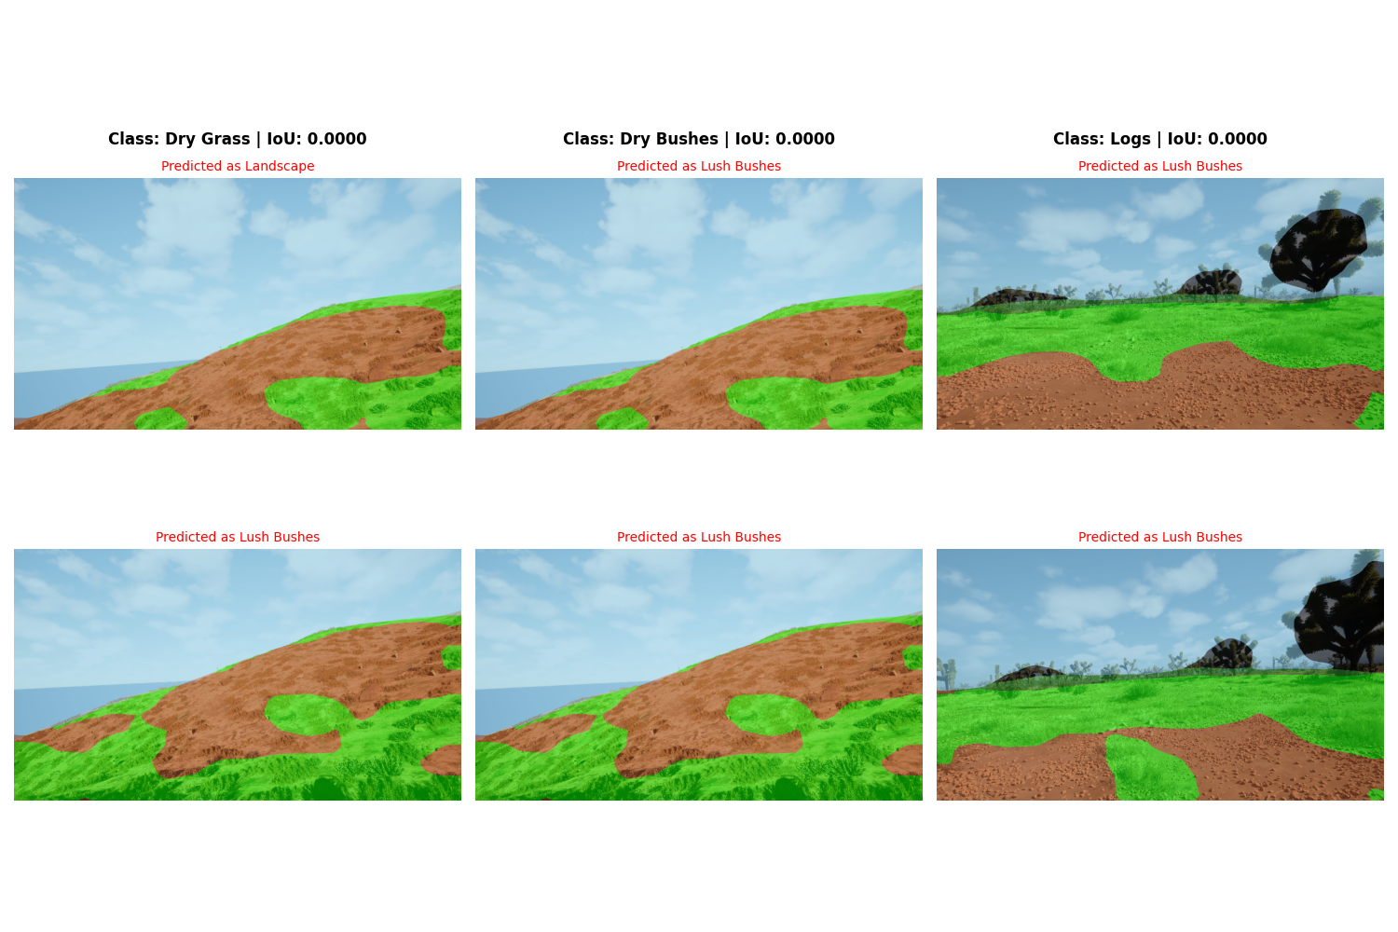
Dry Grass (IoU: 0.0000): The model consistently confused this class with Landscape. This stems from the high visual similarity between these terrain types under varying lighting conditions both share similar colour histograms and texture frequencies at 128×128 resolution.
Dry Bushes (IoU: 0.0000): The model consistently confused this class with Lush Bushes. This stems from the high visual similarity between these terrain types under varying lighting conditions both share similar colour histograms and texture frequencies at 128×128 resolution.
Logs (IoU: 0.0000): The model consistently confused this class with Lush Bushes. This stems from the high visual similarity between these terrain types under varying lighting conditions both share similar colour histograms and texture frequencies at 128×128 resolution.

Current Limitation
The classes Dry Grass, Dry Bushes, Logs achieved an IoU of 0.00 on the validation set. This is an unresolved limitation of the current submission the model failed to learn discriminative features for these categories within the available training time and compute budget. Proposed remediation strategies are documented in the Future Work section.

Conclusion & Future Work

Conclusion
This submission presents a FCN based semantic segmentation model trained entirely from scratch on the Duality AI Offroad Segmentation Dataset under CPU only constraints. The model achieved a best mean IoU of 0.3119 at epoch 45, demonstrating that lightweight architectures combined with principled class weighting can produce meaningful scene understanding in off road environments within a hackathon time limit. Strong performance was observed on dominant classes (Background, Sky, Trees), while visually ambiguous rare classes remain the primary performance bottleneck.

Future Work
- Replace VGG16 encoder with ResNet50 for richer, deeper feature representations.
- Add batch normalization throughout the network to stabilize training.
- Implement stronger color and texture augmentations (HSV jitter, random grayscale, random saturation shifts) to help distinguish visually similar classes such as Dry Grass, Dry Bushes, and Logs that currently achieve near zero IoU.
- Experiment with dilated convolutions in place of late stage pooling to preserve spatial resolution.
- Explore Dice Loss or Focal Loss as alternatives to weighted cross entropy for direct IoU optimization.
- Increase training resolution (256×256 or 320×320) once GPU resources are available.

Appendix
Project directory: D:\kfiles\aarvak files\Offroad_Autonomy_Segmentation_Model\duality project\Offroad_Segmentation_Scripts\Duality_Submission\Duality_Submission_Package\FCN
Best model checkpoint: D:\kfiles\aarvak files\Offroad_Autonomy_Segmentation_Model\duality project\Offroad_Segmentation_Scripts\Duality_Submission\Duality_Submission_Package\FCN\runs\best_fcn8s.pth
Validation directory: D:\kfiles\aarvak files\Offroad_Autonomy_Segmentation_Model\duality project\Offroad_Segmentation_Training_Dataset\Offroad_Segmentation_Training_Dataset\val

